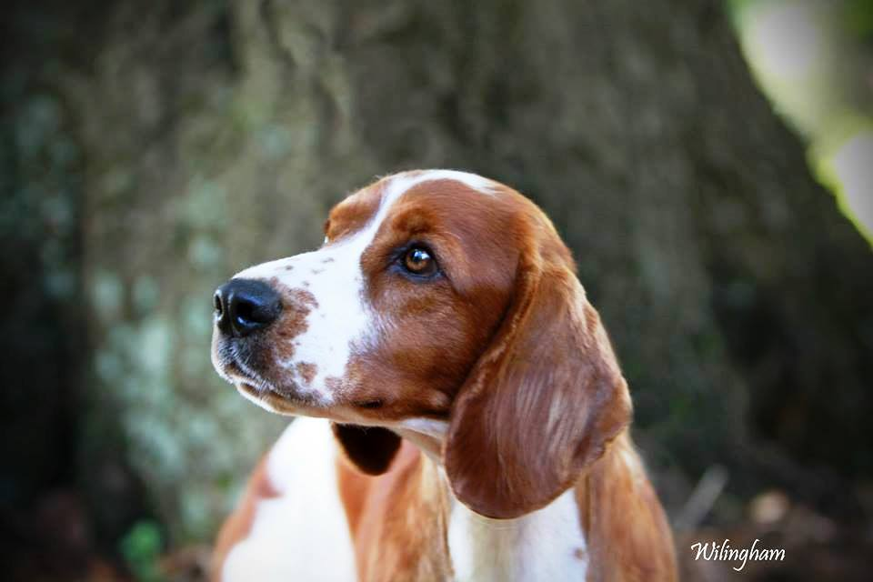
PUPPY SALES ENQUIRY FORM

I / We request the following information because I / We really care about our dogs and the homes they go to and hope you will appreciate just how difficult this can be.
Thank You for your co-operation.

Return to: 'Sarabande' 4, Clos Sant, Teilo, Llangyfelach, SA5 7HG

CONTACT DETAILS
Name:

Address:

Postcode:

Country if not the United Kingdom:

Landline Tel #: Mobile Tel #:

E-mail Address:

Do you have a website? If so; please give us the details
___________________________________________

PROPERTY DETAILS

Your Property is a: Detached | Semi Detached, House | Bungalow, Farm | Smallholding, Flat | Apartment

Your Location is: Rural / Non-Rural

Does the property have its own sole use secure rear garden and how is it secured?

Please State the Approx measurements of your rear garden?

PERSONAL DETAILS

Please tell me a little about your family & your animals etc:

GENERAL DETAILS

How and by what method did you come to make contact?

Please state who the puppy is mainly for or who will be its main carer:

What Age is this person?

Does this person Work? Yes / No please provide details

___________________________________________

PUPPY DETAILS

Do you require your puppy for: Pet / Breeding / Showing?

What sex do you require and why: Boy / Girl

Do you have an objection to a puppy having a show specific fault? If yes, please tell us why?

'KENNEL CLUB' endorsements? if yes please indicate which is objectionable to you and why.
A) Not eligible for issue of an export pedigree
B) Not eligible to be bred from

Please state intended puppy accommodation: Indoor / Outdoor

OTHER DETAILS

Have you had a Welsh Springer Spaniel before Yes / No

Have you had any experience of Welsh Springer Spaniels, if yes please tell us more

Why do you want a Welsh Springer Spaniel

Do you intend to show your Welsh Springer Spaniel? Yes / No

Do you intend to breed from your Welsh Springer Spaniel? Yes / No

Do you intend to neuter/spay your Welsh Springer Spaniel? Yes / No

What made you settle on the Welsh Springer Spaniel?

Does your Family own pets? If yes, please tell us more

EXPECTATIONS

What do you expect from your puppy and / its breed characteristics?

___________________________________________

REFERENCES

Could you provide contact details below for two references if needed.

Name:

Address:

Postcode:

Tel #: Email:

In what capacity do you know this person and for how long?

Name:

Address:

Postcode:

Tel #: Email:

In what capacity do you know this person and for how long?

Please make sure you have checked that these persons are happy to speak to us in this matter.

PLEASE SIGN AND DATE

Signature[s]:___________________________________________________________________Date:_________________________

Signature[s]:___________________________________________________________________Date:_________________________

PROOF OF IDENTITY You may be requested to provide photo proof of identity and / or your address at the time of a sale, please take any such proof with you.

SALES CONTRACT You will be required to complete a sales contract at the time of sale, please check with the individual breeder prior to purchase if you have any concerns about the contract contents.

BREEDERS NOTES:

FORM REC’D ON: ……………………………………………………………………………………………BY.POST / EMAIL / BY HAND

SPOKEN ON TELE: YES / NO PUPPY PURCHASED: YES / NO PRICE QUOTED: £ ……………………………………....

Deposit Paid:……………………………………………………………………….……………..Date:……………………..…………

ENQUIRY PAST TO: ………………………………………….……………FOLLOWED UP:……………………..…………………..….

Date of Collection: ……………………………………………………………….……………………………………….

Notes:

This is for your information to assist you in your prospective purchase.

Buying a puppy is a major commitment, which both you and the breeder will want to ensure is likely to be successful.
Here are some questions you might want to ask the breeder and which the breeder is likely to want to ask you.

QUESTIONS AS A PURCHASER YOU MAY LIKE TO ASK THE BREEDER[S]

- How long have you been involved with this breed / variety of the breed?
- Can you tell me about the history of the breed?
- How long have you been a Welsh Springer Spaniel?
- How long have you been breeding Welsh Springer Spaniel?
- How many litters do you typically have each year?
- Which Breed Clubs do you belong to?
- Do you participate in breed rescue or support their efforts?
- What is their average life expectancy?
- What health problems does the breed suffer?
- What successes have you had when showing your Welsh Springer Spaniel?
- Which Shows do you typically exhibit at?
- Will you be showing any of this litter?
- Do you withhold UK registration on pet puppies if so for what reason?
- What endorsements, if any, do you put on the puppy's KC papers?
- Why did you breed this particular litter?
- How many of these puppies will you be keeping yourself?
- How much exercise do your dogs get and how much will my puppy need?
- Can you tell me one negative aspect of this breed / breeding, even if it is relatively insignificant?
- Did you take this into consideration when you bred your bitch?
- What is your policy toward a dog of your breeding which may someday need to be returned / re-homed?
- What inoculations do you routinely give your puppies and at what age are puppies released to their new owners?
- If indicated by breed information, do you health screen for any congenital / hereditary diseases? If so what are they?
- What written information on diet and rearing do you provide?
- Will you be willing to offer advice and help in raising this dog if we have any questions or are uncertain about specific training methods?
- Would you describe them as generally outgoing or somewhat reserved?
- Do you provide any incentives to buyers for spaying/neutering this dog / bitch?
- Could you refer us to someone who has bought a dog from you?
- Is the sire of this dog in the area, if you do not own him...and, if so, could you arrange for us to see him?
- On a scale of 1 to 10, how would you rate your breed as an all-around "family" dog?
The answers should give you a fairly good idea about the breeder's motivations for having the puppies, the way they keep their own dogs and the sort of after-sales service you are likely to get.

THE FOLLOWING IS A CHECKLIST FOR THE POTENTIAL CUSTOMER
  - Kennel Club Registration / Pedigree
  - Breed Health Screening
  - Worming Programme
  - Permanent ID of animal and Vaccinations
  - Lifetime Support
  - Six Weeks Insurance Cover
  - General Puppy Information Sheet
  - Puppy Pack Containing Food etc

